What is framework in Java?

Framework is a specific pattern of coding. In definite way to code.

N developers are developing a very large application, to make the development process streamlined all write code adhering to a framework avoiding future code design confusions.

Frameworks are large bodies (usually many classes) of prewritten code to which you add your own code to solve a problem in a specific domain.

Spring provides a light-weight solution for building enterprise-ready applications, while still supporting the possibility of using declarative transaction
management, remote access to your logic using RMI or web services, and various options for persisting your
data to a database

The Core package is the most fundamental part of the framework and provides the IoC and Dependency, Injection features

/*
The basic concept here is the BeanFactory , which provides a sophisticated implementation of the factory pattern which removes the need for programmatic singletons and allows you to decouple the configuration and specification of dependencies from your actual program logic

*/

Factory Method Pattern

A Factory Pattern or Factory Method Pattern says that just define an interface or abstract class for creating an object but let the subclasses decide which class to instantiate.

In other words, subclasses are responsible to create the instance of the class.

Advantage of Factory Design Pattern

- Factory Method Pattern allows the sub-classes to choose the type of objects to create.
- It promotes the loose-coupling by eliminating the need to bind application-specific classes into the code. That means the code interacts solely with the resultant interface or abstract class, so that it will work with any classes that implement that interface or that extends that abstract class.

Usage of Factory Design Pattern
- When a class doesn't know what sub-classes will be required to create
- When a class wants that its sub-classes specify the objects to be created.
- When the parent classes choose the creation of objects to its sub-classes.

UML for Factory Method Pattern

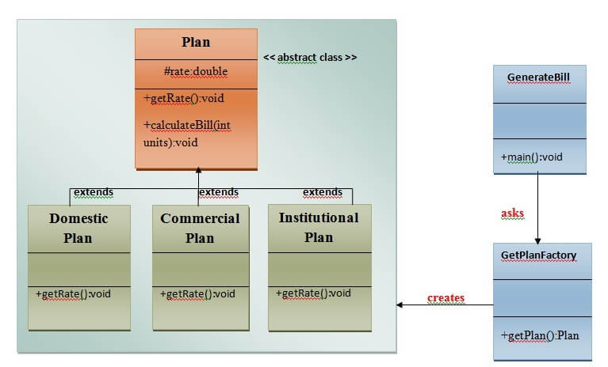

Singleton design pattern in Java

Singleton Pattern says that just"define a class that has only one instance and provides a global point of access to it".

In other words, a class must ensure that only single instance should be created and single object can be used by all other classes.
There are two forms of singleton design pattern
- Early Instantiation: creation of instance at load time.
- Lazy Instantiation: creation of instance when required.

Advantage of Singleton design pattern
- Saves memory because object is not created at each request. Only single instance is reused again and again

Usage of Singleton design pattern
- Singleton pattern is mostly used in multi-threaded and database applications. It is used in logging, caching, thread pools, configuration settings etc.

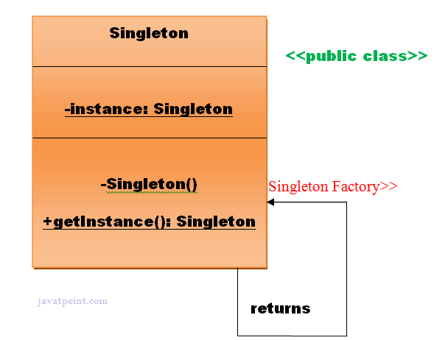

How to create Singleton design pattern?

To create the singleton class, we need to have static member of class, private constructor and static factory method.
- Static member: It gets memory only once because of static, itcontains the instance of the Singleton class.
- Private constructor: It will prevent to instantiate the Singleton class from outside the class.
- Static factory method: This provides the global point of access to the Singleton object and returns the instance to the caller.

class A
{
private static A obj=new A();//Early, instance will be created at load time

private A()
{
}

public static A getA()
{
return obj;
}

public void doSomething()
{
//write your code
}
}

Understanding lazy Instantiation of Singleton Pattern

class A{
private static A obj;
private A(){}

public static A getA(){
if (obj == null){
synchronized(Singleton.class){
if (obj == null){
obj = new Singleton();//instance will be created at request time
}
}
}
return obj;
}

public void doSomething(){
//write your code
}
}

The Context package

build on the solid base provided by the Core package:

it provides a way to access objects in a framework-style manner in a fashion somewhat reminiscent of a JNDI-registry.

The context package inherits its features from the beans package and adds support for internationalization (I18N) (using for example
resource bundles), event-propagation, resource-loading, and the transparent creation of contexts by, for
example, a servlet container.

The DAO package

provides a JDBC-abstraction layer that removes the need to do tedious JDBC coding and parsing of database-vendor specific error codes. Also, the JDBC package provides a way to do programmatic as
well as declarative transaction management, not only for classes implementing special interfaces, but for all
your POJOs (plain old Java objects).

The ORM package

provides integration layers for popular object-relational mapping APIs, including JPA, JDO,
Hibernate, and iBatis. Using the ORM package you can use all those O/R-mappers in combination with all the
other features Spring offers, such as the simple declarative transaction management feature mentioned
previously.

Spring's ORM support is integrated with JPA, Hibernate, JDO and
iBatis;

for example, when using Hibernate, you can continue to use your existing mapping files and standard
Hibernate SessionFactory configuration.

Spring's Web package

provides basic web-oriented integration features, such as multipart file-upload
functionality, the initialization of the IoC container using servlet listeners and a web-oriented application
context. When using Spring together with WebWork or Struts, this is the package to integrate with.

Spring's MVC package

provides a Model-View-Controller (MVC) implementation for web-applications.
Spring's MVC framework is not just any old implementation; it provides a clean separation between domain
model code and web forms, and allows you to use all the other features of the Spring Framework.

The Inversion of Control (IoC) container

IoC Introduction

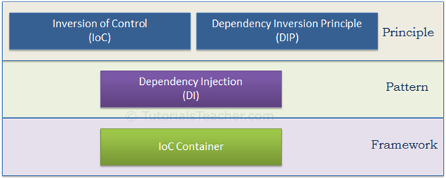

As illustrated in the above figure,

- IoC and DIP are high level design principles which should be used while designing application classes.

- As they are principles, they recommend certain best practices but do not provide any specific implementation details.

- Dependency Injection (DI) is a pattern and IoC container is a framework.

Inversion of Control (is a design principle)

IoC is a design principle which recommends the inversion of different kinds of controls in object-oriented design to achieve loose coupling between application classes.
such as control over the flow of an application,
or control over the dependent object creation and binding (Remember SRP - Single Responsibility Principle).
If you want to do TDD (Test Driven Development), then you must use the IoC principle, without which TDD is not possible. Learn about IoC in detail in the next chapter.Dependency Inversion Principle

Dependency Inversion Principle (is a design principle)

The DIP principle also helps in achieving loose coupling between classes. It is highly recommended to use DIP and IoC together in order to achieve loose coupling.

DIP suggests that high-level modules should not depend on low level modules. Both should depend on abstraction.

Dependency Injection

Dependency Injection (DI) is a design pattern which implements the IoC principle to invert the creation of dependent objects. We will learn about it in the DI chapter.

IoC Container

The IoC container is a framework used to manage automatic dependency injection throughout the application, so that we as programmers do not need to put more time and effort into it.

We cannot achieve loosely coupled classes by using IoC alone. Along with IoC, we also need to use DIP, DI and IoC container. The following figure illustrates how we are going to achieve loosely coupled design step by step in the next few chapters.

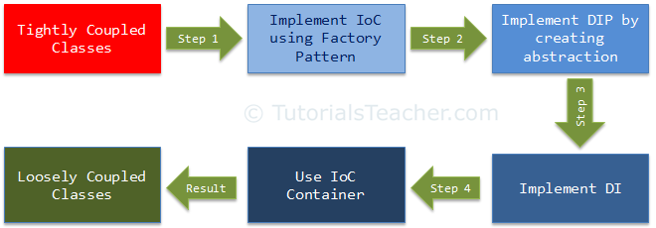

Inversion of Control

Inversion of Control is a principle in software engineering by which the control of objects or portions of a program is transferred to a container or framework. It's most often used in the context of object-oriented programming.

By contrast with traditional programming, in which our custom code makes calls to a library, IoC enables a framework to take control of the flow of a program and make calls to our custom code.

To enable this, frameworks use abstractions with additional behavior built in. If we want to add our own behavior, we need to extend the classes of the framework or plugin our own classes.
The advantages of this architecture are:

- decoupling the execution of a task from its implementation
- making it easier to switch between different implementations
- greater modularity of a program
- greater ease in testing a program by isolating a component or mocking its dependencies and allowing components to communicate through contracts

Inversion of Control (IoC) is a design principle (although, some people refer to it as a pattern).

As the name suggests, it is used to invert different kinds of controls in object-oriented design to achieve loose coupling.

Here, controls refer to any additional responsibilities a class has, other than its main responsibility.

This include control over the flow of an application, and control over the flow of an object creation or dependent object creation and binding.

IoC is all about inverting the control.
To explain this in layman's terms, suppose you drive a car to your work place. This means you control the car. The IoC principle suggests to invert the control, meaning that instead of driving the car yourself, you hire a cab, where another person will drive the car. Thus, this is called inversion of the control - from you to the cab driver.

You don't have to drive a car yourself and you can let the driver do the driving so that you can focus on your main work.

The IoC principle helps in designing loosely coupled classes which make them testable, maintainable and extensible.

Control Over the Dependent Object Creation

IoC can also be applied when we create objects of a dependent class. First of all, let's understand what we mean by dependency here.

Consider the following example.
public class A
{
B b;

public A()
{
b = new B();
}

public void Task1() {
// do something here..
b.SomeMethod();
// do something here..
}

}

public class B {

public void SomeMethod() {
//doing something..
}
}

- class A calls b.SomeMethod() to complete its task1.
- Class A cannot complete its task without class B and so you can say that "Class A is dependent on class B" or "class B is a dependency of class A".

In the object-oriented design approach, classes need to interact with each other in order to complete one or more functionalities of an application, such as in the above example - classes A and B. Class A creates and manages the life time of an object of class B. Essentially, it controls the creation and life time of objects of the dependency class.

The IoC principle suggests to invert the control. This means to delegate the control to another class. In other words, invert the dependency creation control from class A to another class, as shown below.

public class A
{
B b;

public A()
{
b = Factory.GetObjectOfB ();
}

public void Task1() {
// do something here..
b.SomeMethod();
// do something here..
}
}

public class Factory
{
public static B GetObjectOfB()
{
return new B();
}
}

new keyword giving the null expation
As you can see above, class A uses Factory class to get an object of class B. Thus, we have inverted the dependent object creation from class A to Factory. Class A no longer creates an object of class B, instead it uses the factory class to get the object of class B.

Let's understand this using a more practical example.

In an object-oriented design, classes should be designed in a loosely coupled way. Loosely coupled means changes in one class should not force other classes to change, so the whole application can become maintainable and extensible.

Let's understand this by using typical n-tier architecture as depicted by the following figure:



In the typical n-tier architecture, the User Interface (UI) uses Service layer to retrieve or save data. The Service layer uses the BusinessLogic class to apply business rules on the data. The BusinessLogic class depends on the DataAccess class which retrieves or saves the data to the underlying database. This is simple n-tier architecture design. Let's focus on the BusinessLogic and DataAccess classes to understand IoC.
The following is an example of BusinessLogic and DataAccess classes for a customer.

public class CustomerBusinessLogic
{
DataAccess _dataAccess;

public CustomerBusinessLogic()
{
_dataAccess = new DataAccess();
}

public string GetCustomerName(int id)
{
return _dataAccess.GetCustomerName(id);
}
}

public class DataAccess
{
public DataAccess()
{
}

public string GetCustomerName(int id) {
return "Dummy Customer Name"; // get it from DB in real app
}
}

As you can see in the above example, the CustomerBusinessLogic class depends on the DataAccess class. It creates an object of the DataAccess class to get the customer data.

Now, let's understand what's wrong with the above classes

In the above example, CustomerBusinessLogic and DataAccess are tightly coupled classes because the CustomerBusinessLogic class includes the reference of the concrete DataAccess class. It also creates an object of DataAccess class and manages the lifetime of the object.

Problems in the above example classes:

- CustomerBusinessLogic and DataAccess classes are tightly coupled classes. So, changes in the DataAccess class will lead to changes in the CustomerBusinessLogic class. For example, if we add, remove or rename any method in the DataAccess class then we need to change the CustomerBusinessLogic class accordingly.
- Suppose the customer data comes from different databases or web services and, in the future, we may need to create different classes, so this will lead to changes in the CustomerBusinessLogic class.
- The CustomerBusinessLogic class creates an object of the DataAccess class using the new keyword. There may be multiple classes which use the DataAccess class and create its objects. So, if you change the name of the class, then you need to find all the places in your source code where you created objects of DataAccess and make the changes throughout the code. This is repetitive code for creating objects of the same class and maintaining their dependencies.
- Because the CustomerBusinessLogic class creates an object of the concrete DataAccess class, it cannot be tested independently (TDD). The DataAccess class cannot be replaced with a mock class.

To solve all of the above problems and get a loosely coupled design, we can use the IoC and DIP principles together. Remember, IoC is a principle, not a pattern. It just gives high-level design guidelines but does not give implementation details. You are free to implement the IoC principle the way you want.

The following pattern (but not limited) implements the IoC principle.

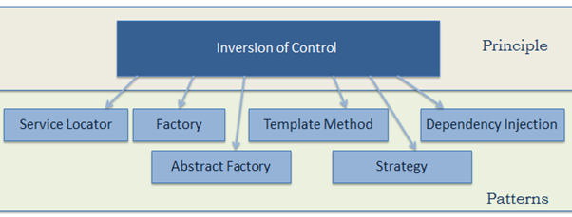

Let's use the Factory pattern to implement IoC in the above example, as the first step towards attaining loosely coupled classes.
First, create a simple Factory class which returns an object of the DataAccess class as shown below.

public class DataAccessFactory
{
public static DataAccess GetDataAccessObj()
{
return new DataAccess();
}
}

Now, use this DataAccessFactory class in the CustomerBusinessLogic class to get an object of DataAccess class.

public class CustomerBusinessLogic
{

public CustomerBusinessLogic()
{
}

public string GetCustomerName(int id)
{
DataAccess _dataAccess = DataAccessFactory.GetDataAccessObj();

return _dataAccess.GetCustomerName(id);
}
}

As you can see, the CustomerBusinessLogic class uses the DataAccessFactory.GetCustomerDataAccessObj() method to get an object of the DataAccess class instead of creating it using the new keyword. Thus, we have inverted the control of creating an object of a dependent class from the CustomerBusinessLogic class to the DataAccessFactory class.
This is a simple implementation of IoC and the first step towards achieving fully loose coupled design. As m15entioned in the previous chapter, we will not achieve complete loosely coupled classes by only using IoC. Along with IoC, we also need to use DIP, Strategy pattern, and DI (Dependency Injection).

Dependency Inversion Principle

In the previous chapter, we learned about implementing the IoC principle using the Factory pattern and achieved the first level of loosely coupled design.

Here, we will learn how to implement the Dependency Inversion Principle as the second step to achieve loosely coupled classes.

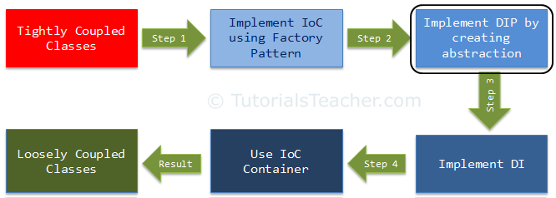

DIP is one of the SOLID object-oriented principle invented by Robert Martin (a.k.a. Uncle Bob)

DIP Definition

High-level modules should not depend on low-level modules. Both should depend on the abstraction.
- High-level modules should not depend on low-level modules. Both should depend on the abstraction.
- Abstractions should not depend on details. Details should depend on abstractions.

public class CustomerBusinessLogic
{
public CustomerBusinessLogic()
{
}

public string GetCustomerName(int id)
{
DataAccess _dataAccess = DataAccessFactory.GetDataAccessObj();

return _dataAccess.GetCustomerName(id);
}
}

public class DataAccessFactory
{
public static DataAccess GetDataAccessObj()
{
return new DataAccess();
}
}

public class DataAccess
{
public DataAccess()
{
}

public string GetCustomerName(int id) {
return "Dummy Customer Name"; // get it from DB in real app
}
}

In the above example, we implemented the factory pattern to achieve IoC. But, the CustomerBusinessLogic class uses the concrete DataAccess class. Therefore, it is still tightly coupled, even though we have inverted the dependent object creation to the factory class.
Let's use DIP on the CustomerBusinessLogic and DataAccess classes and make them more loosely coupled.
As per the DIP definition, a high-level module should not depend on low-level modules.

Both should depend on abstraction. So, first, decide which is the high-level module (class) and the low-level module. A high-level module is a module which depends on other modules. In our example, CustomerBusinessLogic depends on the DataAccess class, so CustomerBusinessLogic is a high-level module and DataAccess is a low-level module. So, as per the first rule of DIP, CustomerBusinessLogic should not depend on the concrete DataAccess class, instead both classes should depend on abstraction.

The second rule in DIP is "Abstractions should not depend on details. Details should depend on abstractions".

What is an Abstraction?

Abstraction and encapsulation are important principles of object-oriented programming. There are many different definitions from different people, but let's understand abstraction using the above example.

Now, what should be in the interface (or in the abstract class)? As you can see, CustomerBusinessLogic uses the GetCustomerName() method of the DataAccess class (in real life, there will be many customer-related methods in the DataAccess class). So, let's declare the GetCustomerName(int id) method in the interface, as shown below.

public interface ICustomerDataAccess
{
string GetCustomerName(int id);
}

Now, implement ICustomerDataAccess in the CustomerDataAccess class, as shown below (so, instead of the DataAccess class, let's define the new CustomerDataAccess class).

public class CustomerDataAccess extends ICustomerDataAccess
{
public CustomerDataAccess()
{
}

public string GetCustomerName(int id) {
return "Dummy Customer Name";
}
}

Now, we need to change our factory class which returns ICustomerDataAccess instead of the concrete DataAccess class, as shown below.

public class DataAccessFactory
{
public static ICustomerDataAccess GetCustomerDataAccessObj()
{
return new CustomerDataAccess();
}
}

Now, change the CustomerBusinessLogic class which uses ICustomerDataAccess instead of the concrete DataAccess, class as shown below.

public class CustomerBusinessLogic
{
ICustomerDataAccess _custDataAccess;

public CustomerBusinessLogic()
{
_custDataAccess = DataAccessFactory.GetCustomerDataAccessObj();
}

public string GetCustomerName(int id)
{
return _custDataAccess.GetCustomerName(id);
}
}

Thus, we have implemented DIP in our example where a high-level module (CustomerBusinessLogic) and low-level module (CustomerDataAccess) are dependent on an abstraction (ICustomerDataAccess). Also, the abstraction (ICustomerDataAccess) does not depend on details (CustomerDataAccess), but the details depend on the abstraction.
The following is the complete DIP example discussed so far.

public interface ICustomerDataAccess
{
string GetCustomerName(int id);
}

public class CustomerDataAccess: ICustomerDataAccess
{
public CustomerDataAccess() {
}

public string GetCustomerName(int id) {
return "Dummy Customer Name";
}
}

public class DataAccessFactory
{
public static ICustomerDataAccess GetCustomerDataAccessObj()
{
return new CustomerDataAccess();
}
}

public class CustomerBusinessLogic
{
ICustomerDataAccess _custDataAccess;

public CustomerBusinessLogic()
{
_custDataAccess = DataAccessFactory.GetCustomerDataAccessObj();
}

public string GetCustomerName(int id)
{
return _custDataAccess.GetCustomerName(id);
}
}

The advantages of implementing DIP in the above example is that the CustomerBusinessLogic and CustomerDataAccess classes are loosely coupled classes because CustomerBusinessLogic does not depend on the concrete DataAccess class, instead it includes a reference of the ICustomerDataAccess interface. So now, we can easily use another class which implements ICustomerDataAccess with a different implementation.
Still, we have not achieved fully loosely coupled classes because the CustomerBusinessLogic class includes a factory class to get the reference of ICustomerDataAccess. This is where the Dependency Injection pattern helps us. In the next chapter, we will learn how to use the Dependency Injection (DI) and the Strategy pattern using the above example.

IoC Container

IoC Container (a.k.a. DI Container) is a framework for implementing automatic dependency injection. It manages object creation and it's life-time, and also injects dependencies to the class.

The IoC container creates an object of the specified class and also injects all the dependency objects through a constructor , and setter and getter

All the containers must provide easy support for the following DI lifecycle.

Register: The container must know which dependency to instantiate when it encounters a particular type. This process is called registration. Basically, it must include some way to register type-mapping.

Resolve: When using the IoC container, we don't need to create objects manually. The container does it for us. This is called resolution. The container must include some methods to resolve the specified type; the container creates an object of the specified type, injects the required dependencies if any and returns the object.

Dispose: The container must manage the lifetime of the dependent objects. Most IoC containers include different lifetimemanagers to manage an object's lifecycle and dispose it.

Spring - IoC Containers

Spring IoC is the mechanism to achieve loose-coupling between Objects dependencies. To achieve loose coupling and dynamic binding of the objects at runtime,

Spring IoC container is the program that injects dependencies into an object and make it ready for our use.

BeanFactory is the root interface of Spring IoC container.

ApplicationContext is the child interface of BeanFactory interface that provide Spring AOP features, i18n etc

The Spring container is at the core of the Spring Framework. The container will create the objects, wire them together, configure them, and manage their complete life cycle from creation till destruction.

Spring container uses DI to manage the components that make up an application. These objects are called Spring Beans,

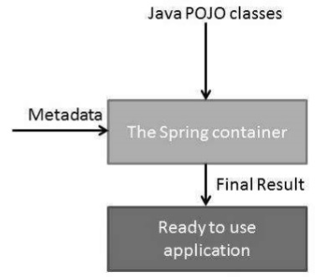

Spring Bean
Spring Bean is nothing special, any object in the Spring framework that we initialize through Spring container is called Spring Bean. Any normal Java POJO class can be a Spring Bean if it’s configured to be initialized via container by providing configuration metadata information.
Spring Bean Scopes
There are five scopes defined for Spring Beans.3. What Is Dependency Injection?

- singleton – Only one instance of the bean will be created for each container.

This is the default scope for the spring beans. While using this scope, make sure bean doesn’t have shared instance variables otherwise it might lead to data inconsistency issues.

- prototype – A new instance will be created every time the bean is requested.

- request – This is same as prototype scope, however it’s meant to be used for web applications. A new instance of the bean will be created for each HTTP request.
- session – A new bean will be created for each HTTP session by the container.
- global-session – This is used to create global session beans for Portlet applications.

Spring Framework is extendable and we can create our own scopes too. However, most of the times we are good with the scopes provided by the framework

Spring Bean Configuration
Spring Framework provides three ways to configure beans to be used in the application.

- Annotation Based Configuration – By using @Service or @Component annotations. Scope details can be provided with @Scope annotation.

- XML Based Configuration – By creating Spring Configuration XML file to configure the beans. If you are using Spring MVC framework, the xml based configuration can be loaded automatically by writing some boiler plate code in web.xml file.
- Java Based Configuration – Starting from Spring 3.0, we can configure Spring beans using java programs. Some important annotations used for java based configuration are @Configuration, @ComponentScan and @Bean.

Spring provides the following two distinct types of containers

Spring BeanFactory Container

This is the simplest container providing the basic support for DI and is defined by the org.springframework.beans.factory.BeanFactory interface. The BeanFactory and related interfaces, such as BeanFactoryAware, InitializingBean, DisposableBean, are still present in Spring for the purpose of backward compatibility with a large number of third-party frameworks that integrate with Spring.

Spring ApplicationContext Container
This container adds more enterprise-specific functionality such as the ability to resolve textual messages from a properties file and the ability to publish application events to interested event listeners. This container is defined by the org.springframework.context.ApplicationContext interface. such as BeanFactoryAware, InitializingBean, DisposableBean, are still present in Spring for the purpose of backward compatibility with a large number of third-party frameworks that integrate with Sp

Let us take a look at a working Eclipse IDE in place and take the following steps to create a Spring application −
Steps | Description
1 | Create a project with a name SpringExample and create a packagecom.tutorialspoint under the src folder in the created project.
2 | Add the required Spring libraries using Add External JARs option as explained in the Spring Hello World Example chapter.
3 | Create Java classes HelloWorld and MainApp under the com.tutorialspointpackage.
4 | Create Beans configuration file Beans.xml under the src folder.
5 | The final step is to create the content of all the Java files and Bean Configuration file. Finally, run the application as explained below.

3. What Is Dependency Injection?

Dependency injection is a pattern through which to implement IoC, where the control being inverted is the setting of object's dependencies.

4. The Spring IoC Container

An IoC container is a common characteristic of frameworks that implement IoC.
In the Spring framework, the IoC container is represented by the interface ApplicationContext. The Spring container is responsible for instantiating, configuring and assembling objects known as beans, as well as managing their lifecycle.

The Spring framework provides several implementations of the ApplicationContext interface — ClassPathXmlApplicationContext and FileSystemXmlApplicationContext for standalone applications, and WebApplicationContext for web applications.

5. Constructor-Based Dependency Injection

In the case of constructor-based dependency injection, the container will invoke a constructor with arguments each representing a dependency we want to set.
Spring resolves each argument primarily by type, followed by name of the attribute and index for disambiguation. Let's see the configuration of a bean and its dependencies using annotations:

@Configuration
public class AppConfig {

@Bean
public Item item1() {
return new ItemImpl1();
}

@Bean
public Store store() {
return new Store(item1());
}
}

6. Setter-Based Dependency Injection

For setter-based DI, the container will call setter methods of our class, after invoking a no-argument constructor or no-argument static factory method to instantiate the bean. Let's create this configuration using annotations:

Field-Based Dependency Injection

In case of Field-Based DI, we can inject the dependencies by marking them with an @Autowired annotation:

public class Store {
@Autowired
private Item item;
}

While constructing the Store object, if there's no constructor or setter method to inject the Item bean, the container will use reflection to inject Item into Store.
We can also achieve this using XML configuration.
This approach might look simpler and cleaner but is not recommended to use because it has a few drawbacks such as:
- This method uses reflection to inject the dependencies, which is costlier than constructor-based or setter-based injection
- It's really easy to keep adding multiple dependencies using this approach. If you were using constructor injection having multiple arguments would have made us think that the class does more than one thing which can violate the Single Responsibility Principle.
More information on @Autowired annotation can be found in Wiring In Spring article.

8. Autowiring Dependencies

Wiring allows the Spring container to automatically resolve dependencies between collaborating beans by inspecting the beans that have been defined.
There are four modes of autowiring a bean using an XML configuration:
- no: the default value – this means no autowiring is used for the bean and we have to explicitly name the dependencies
- byName: autowiring is done based on the name of the property, therefore Spring will look for a bean with the same name as the property that needs to be set
- byType: similar to the byName autowiring, only based on the type of the property. This means Spring will look for a bean with the same type of the property to set. If there's more than one bean of that type, the framework throws an exception.
- constructor: autowiring is done based on constructor arguments, meaning Spring will look for beans with the same type as the constructor arguments

Spring - Bean Life Cycle

The life cycle of a Spring bean is easy to understand. When a bean is instantiated, it may be required to perform some initialization to get it into a usable state.

when the bean is no longer required and is removed from the container, some cleanup may be required.

Spring – IoC Containers

The Spring IoC container is at the core of the Spring Framework.

The container will create the objects, wire them together, configure them, and manage their complete life cycle from creation till destruction

The Spring container uses dependency injection (DI) to manage the components that make up an application.

Spring provides following two types of containers.
- BeanFactory container
- ApplicationContext container

1. BeanFactory

A BeanFactory is essentially nothing more than the interface for an advanced factory capable of maintaining a registry of different beans and their dependencies.
The BeanFactory enables us to read bean definitions and access them using the bean factory.

1.1. How to create BeanFactory

InputStream is = new FileInputStream("beans.xml");
BeanFactory factory = new XmlBeanFactory(is);

//Get bean
HelloWorld obj = (HelloWorld) factory.getBean("helloWorld");

Resource resource = new FileSystemResource("beans.xml");
BeanFactory factory = new XmlBeanFactory(resource);

ClassPathResource resource = new ClassPathResource("beans.xml");
BeanFactory factory = new XmlBeanFactory(resource);

Basically that’s all there is. Using getBean(String), you can retrieve instances of your beans; the client-side view of the BeanFactory is surprisingly simple.

1.2. BeanFactory methods

The BeanFactory interface has only six methods for client code to call:
- boolean containsBean(String): returns true if the BeanFactory contains a bean definition or bean instance that matches the given name
- Object getBean(String): returns an instance of the bean registered under the given name. Depending on how the bean was configured by the BeanFactory configuration, either a singleton and thus shared instance or a newly created bean will be returned. A BeansException will be thrown when either the bean could not be found (in which case it’ll be a NoSuchBeanDefinitionException), or an exception occurred while instantiating and preparing the bean
- Object getBean(String, Class): returns a bean, registered under the given name. The bean returned will be cast to the given Class. If the bean could not be cast, corresponding exceptions will be thrown (BeanNotOfRequiredTypeException). Furthermore, all rules of the getBean(String) method apply (see above)
- Class getType(String name): returns the Class of the bean with the given name. If no bean corresponding to the given name could be found, a NoSuchBeanDefinitionException will be thrown
- boolean isSingleton(String): determines whether or not the bean definition or bean instance registered under the given name is a singleton. If no bean corresponding to the given name could be found, a NoSuchBeanDefinitionException will be thrown
- String[] getAliases(String): Return the aliases for the given bean name, if any were defined in the bean definition

2. ApplicationContext

ApplicationContext container adds more enterprise-specific functionality such as the ability to resolve textual messages from a properties file and the ability to publish application events to interested event listeners.

This container is defined by the org.springframework.context.ApplicationContext interface.

The ApplicationContext container includes all functionality of the BeanFactory container, so it is generally recommended over the BeanFactory.

BeanFactory can still be used for lightweight applications like mobile devices or applet based applications where data volume and speed is significant.

2.1. Types of ApplicationContext
The most commonly used ApplicationContext implementations are:
- FileSystemXmlApplicationContext – This container loads the definitions of the beans from an XML file. Here you need to provide the full path of the XML bean configuration file to the constructor.
- ClassPathXmlApplicationContext – This container loads the definitions of the beans from an XML file. Here you do not need to provide the full path of the XML file but you need to set CLASSPATH properly because this container will look bean configuration XML file in CLASSPATH.
- WebXmlApplicationContext – This container loads the XML file with definitions of all beans from within a web application.

beanfactory vs applicationcontext vs webapplicationcontextSpring – Inversion of Control vs Dependency Injection

Spring – Inversion of Control vs Dependency Injection

In software engineering, inversion of control (IoC) is a programming technique in which object coupling is bound at run time by an assembler object and is typically not known at compile time using static analysis. In this spring tutorial, learn the difference between ioc and dependency injection in spring with example.

1. What is Inversion of Control (IoC)

2. What is Dependency Injection (DI)

IoC relies on dependency injection because a mechanism is needed in order to activate the components providing the specific functionality.

3. How to implement IoC

using a factory pattern
- using a service locator pattern
- using a dependency injection of any given below type:
  - a constructor injection
  - a setter injection
  - an interface injection

4. Inversion of control in Spring

The org.springframework.beans and org.springframework.context packages provide the basis for the Spring Framework’s IoC container.

The BeanFactory interface provides an advanced configuration mechanism capable of managing objects of any nature

The ApplicationContext interface builds on top of the BeanFactory (it is a sub-interface) and adds other functionality such as easier integration with Spring’s AOP features, message resource handling (for use in internationalization), event propagation, and application-layer specific contexts such as the WebApplicationContext for use in web applications.

spring and interfaces

